Chapter 17, Solution 25.

Determine the Fourier series representation of the function in Fig. 17.63.
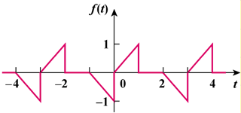

Figure 17.63
For Prob. 17.25.

Solution

This is a half-wave (odd) function since f(t−T/2) = −f(t).

a_{o} = 0, a_{n} = b_{n} = 0 for n = even, T = 3, ω_{o} = 2π/3.

For n = odd,

a_{n} =

=

=

b _{n} =

=

=

f(t) =

